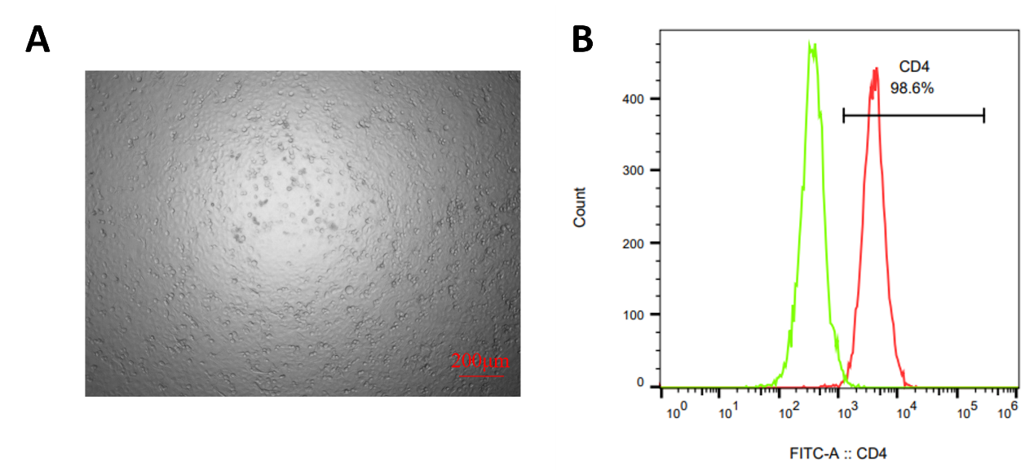
Supplementary Fig. 1. Identification of CD4⁺ T cells. (A) Morphological identification of CD4⁺ cells. Scale bar: 200 μm. Objective: 100×. (B) Flow cytometry identification results.

